1. Create Webmail account via CPANEL (Live_Domain_Name /webmail - Ex. Viiworks.com/webmail)

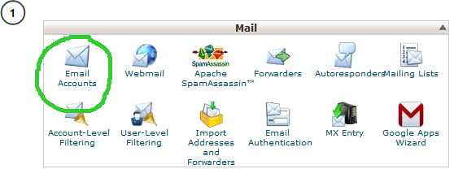

-----

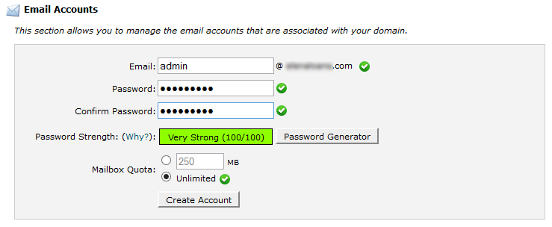

2. Create Gmail account. (https://mail.google.com/ - Ex. admin@gmail.com)

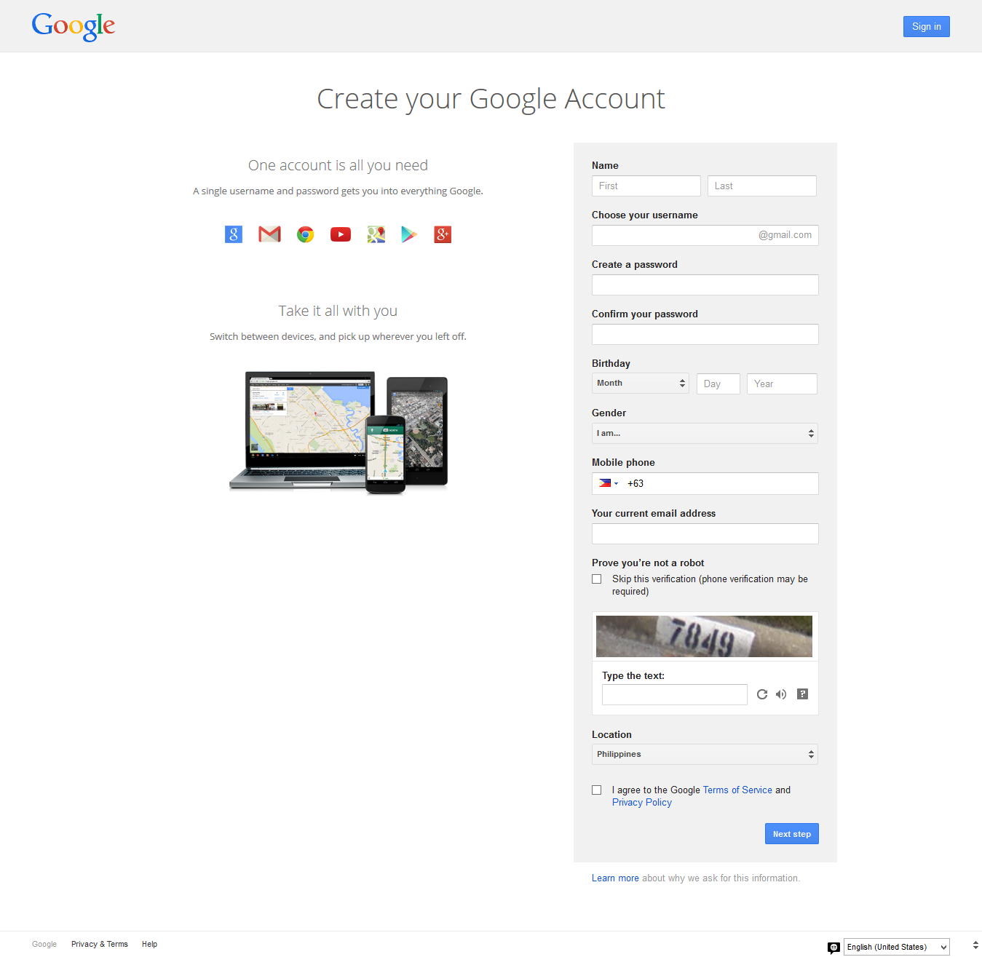

3. Click “Gear Icon” -> “Settings”

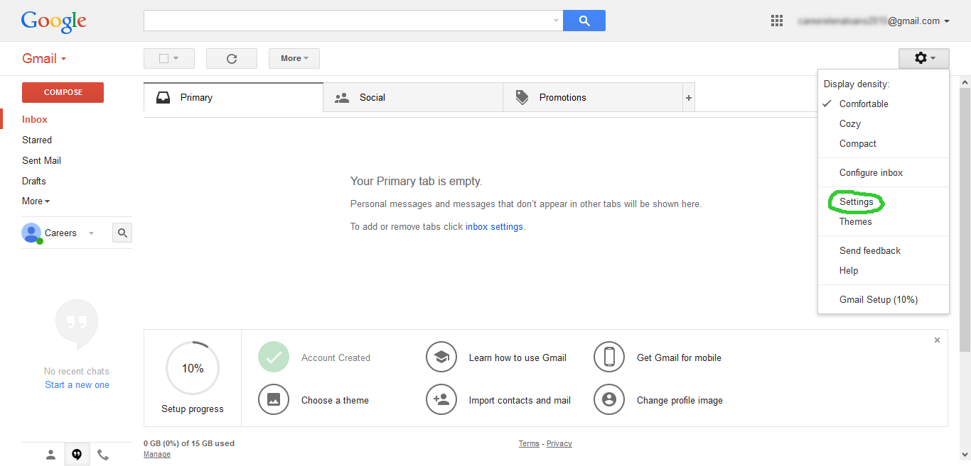

4. Click “Accounts and Import” -> “Add a POP3 mail account you own”

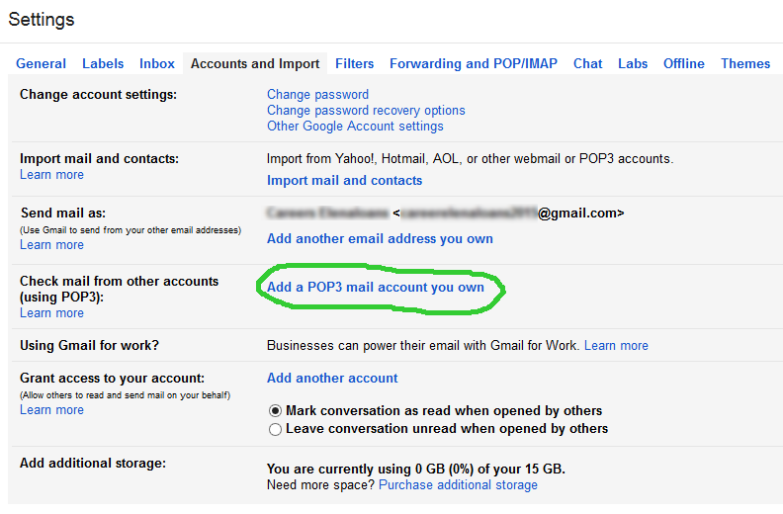

5. A pop up window will appear.

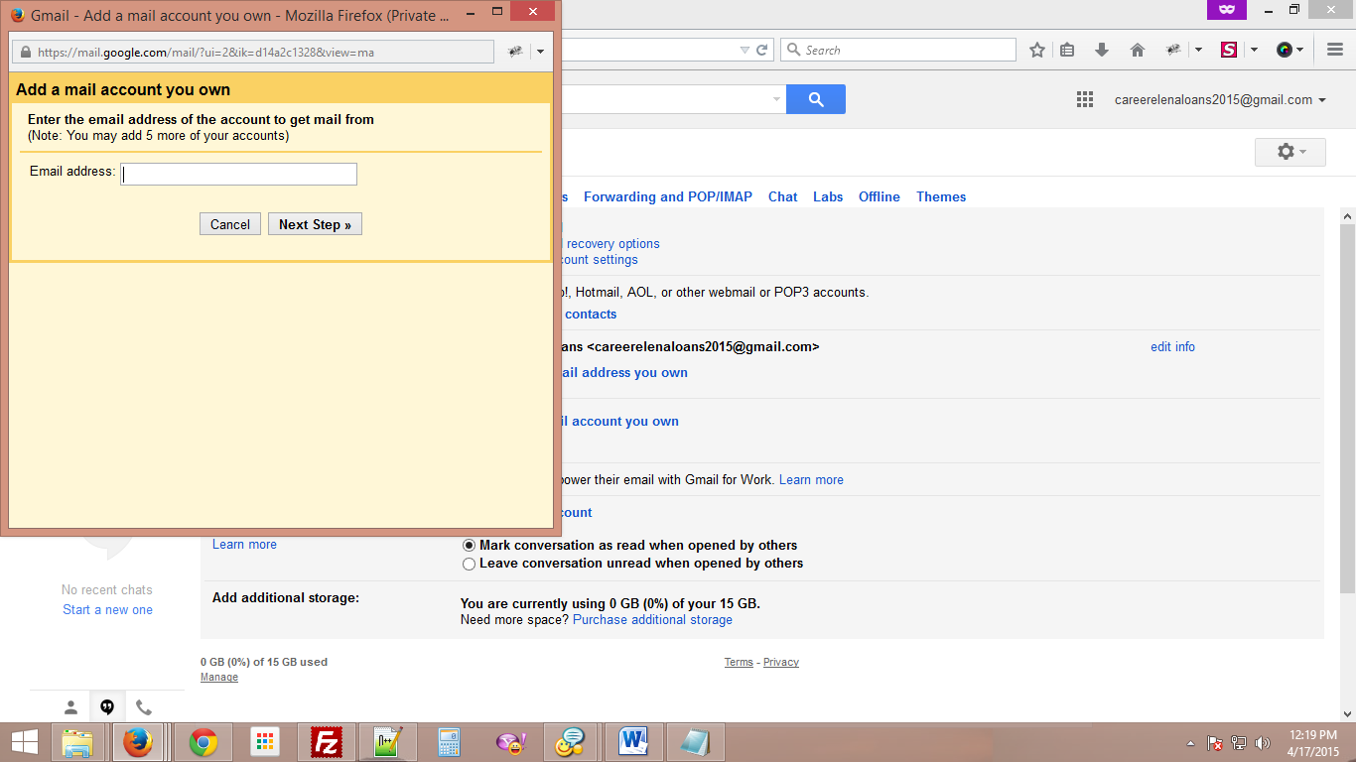

6. Enter the email address created in the webmail, then click “Next Step”.

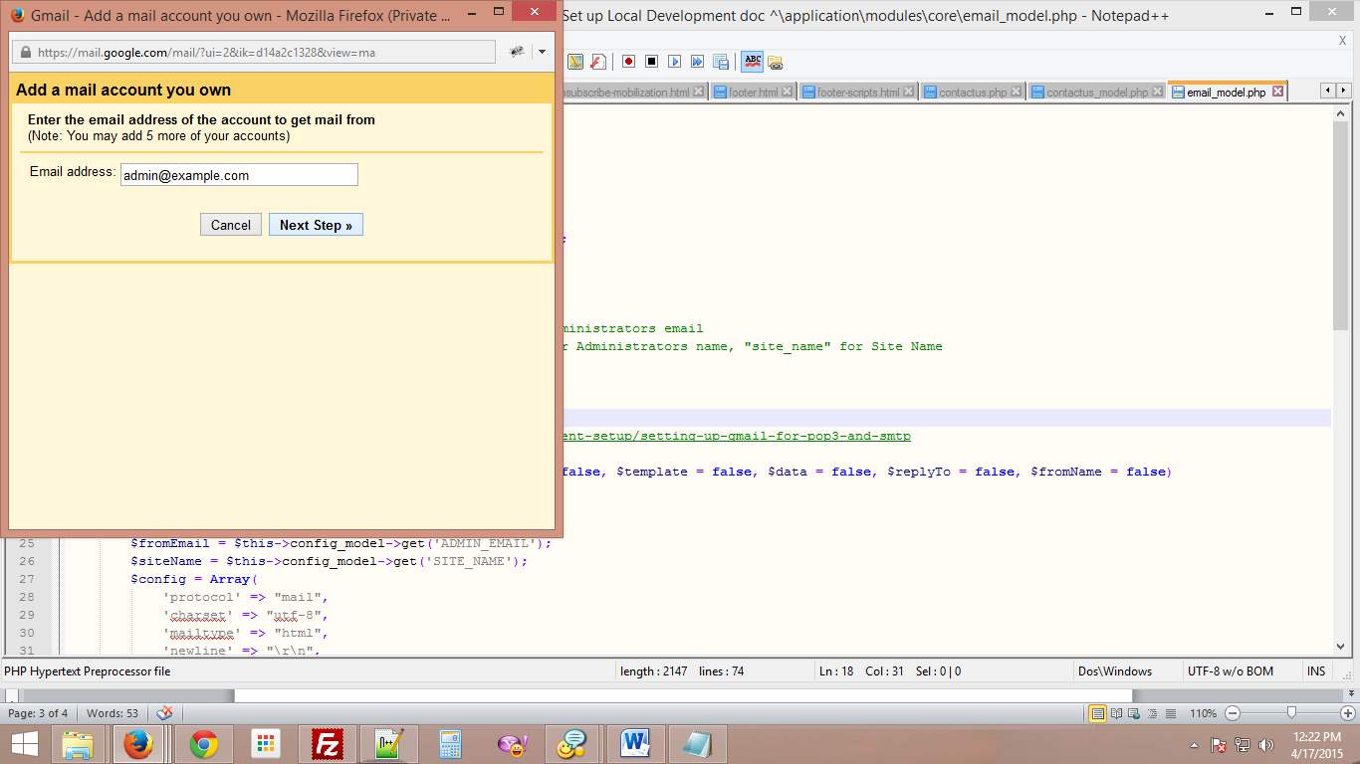

7. Click “Email Accounts” from CPANEL homepage



8. Click “More” -> “Configure Email Client”

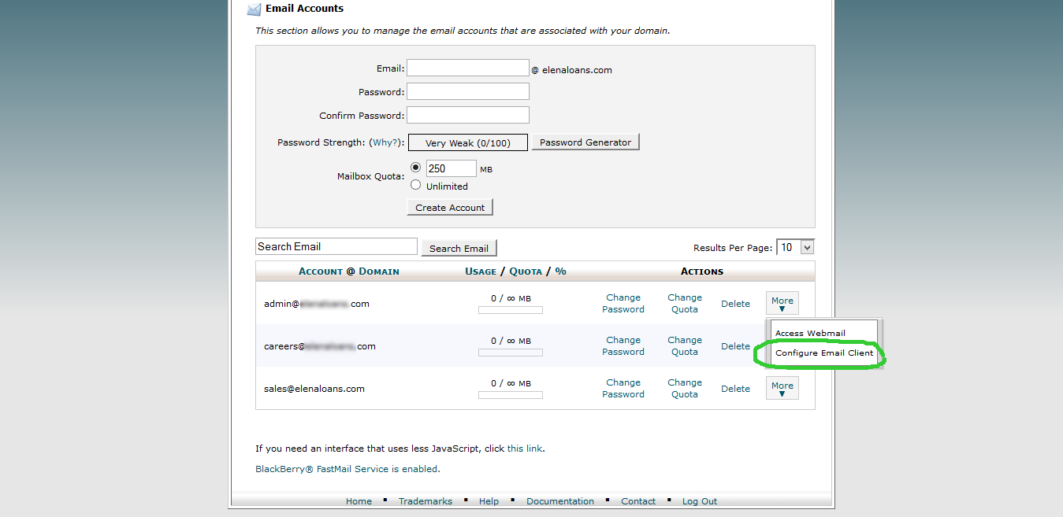

9. Take note of the details under “Manual Settings”

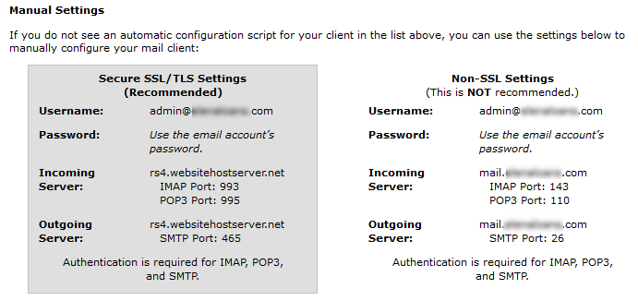

10. In the pop up window. Enter the fields, and then click “Add Account”.

* Username: email created from the CPANEL. #1 ([admin@example.com](mailto:admin@example.com))
* Password: email password created from the CPANEL. #1
* POP Server: from “Non-SSL Settings” -> “Incoming Server”

 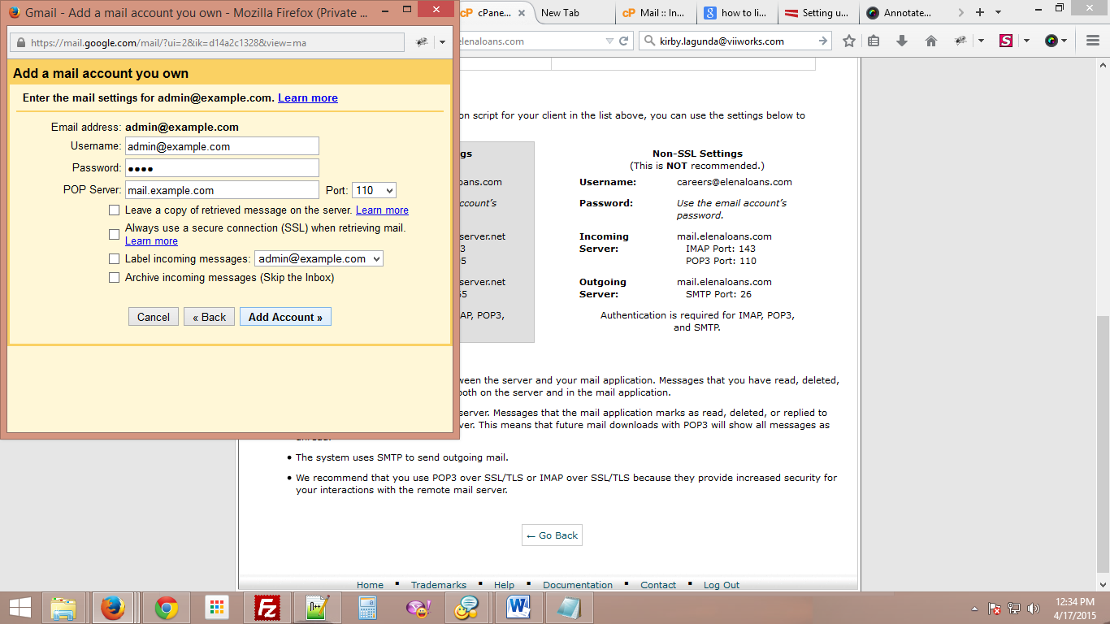

11. Select “Yes, I want to be able to send mail as [admin@example.com](mailto:admin@example.com)”, then click “Next Step”

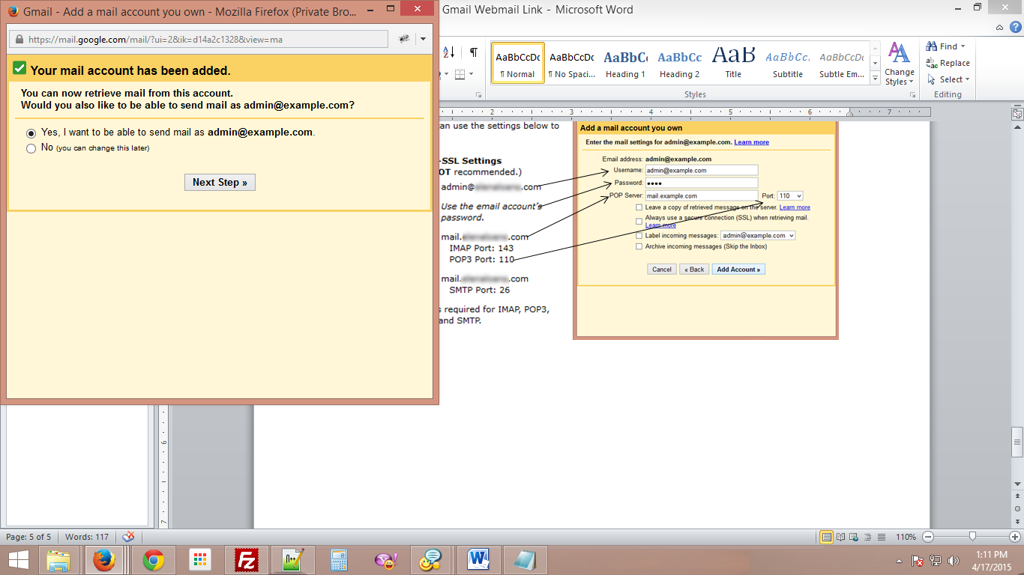

12. Enter a Name for the email address. Check the “Treat as an alias.”, and then click “Next Step”

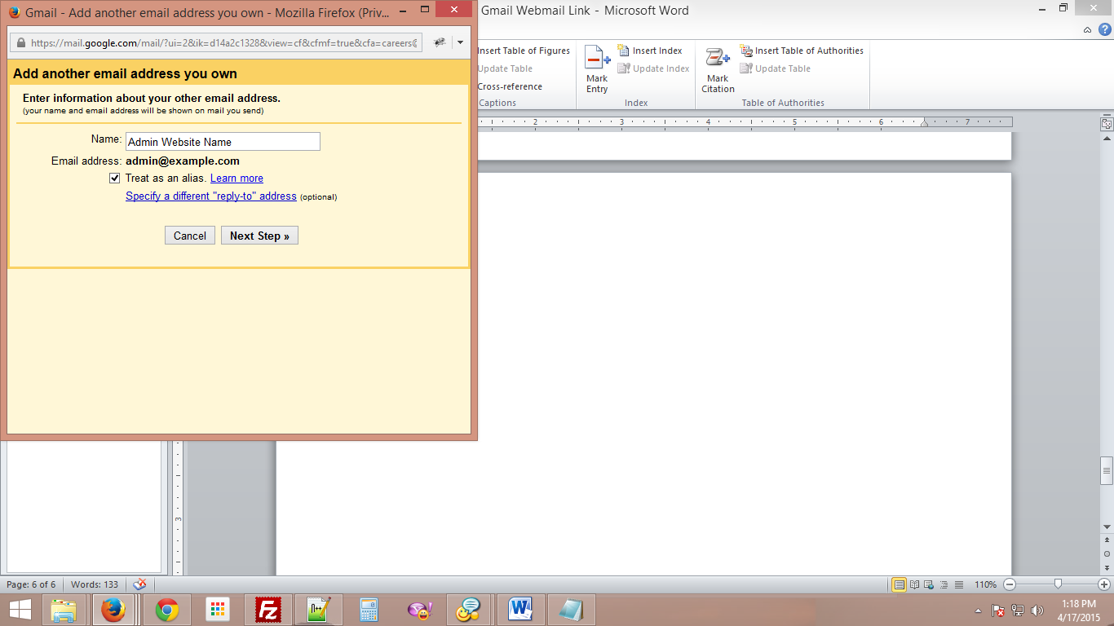

13. Enter the fields, and then click “Add Account”.

* Username: email created from the CPANEL. #1 ([admin@example.com](mailto:admin@example.com))
* Password: email password created from the CPANEL. #1
* SMTP Server: from “Secure SSL/TLS Settings” -> “Outgoing Server”

 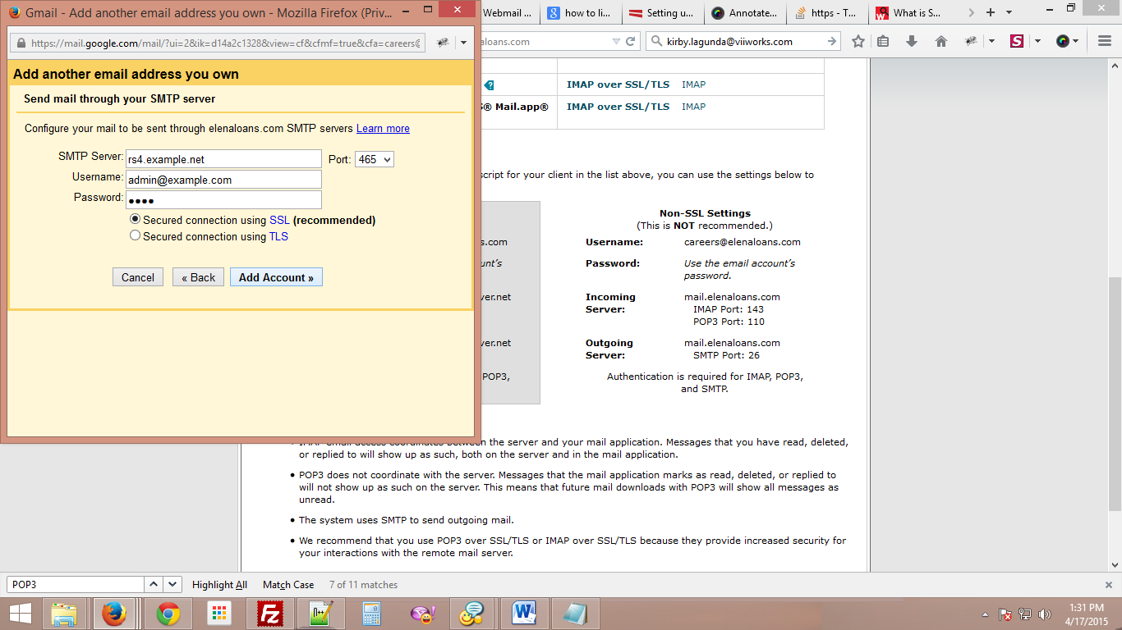

14. Check the inbox in Webmail Account created or Gmail Account created and open “Gmail Confirmation” to get the Confirmation Code, then click “Verify”.

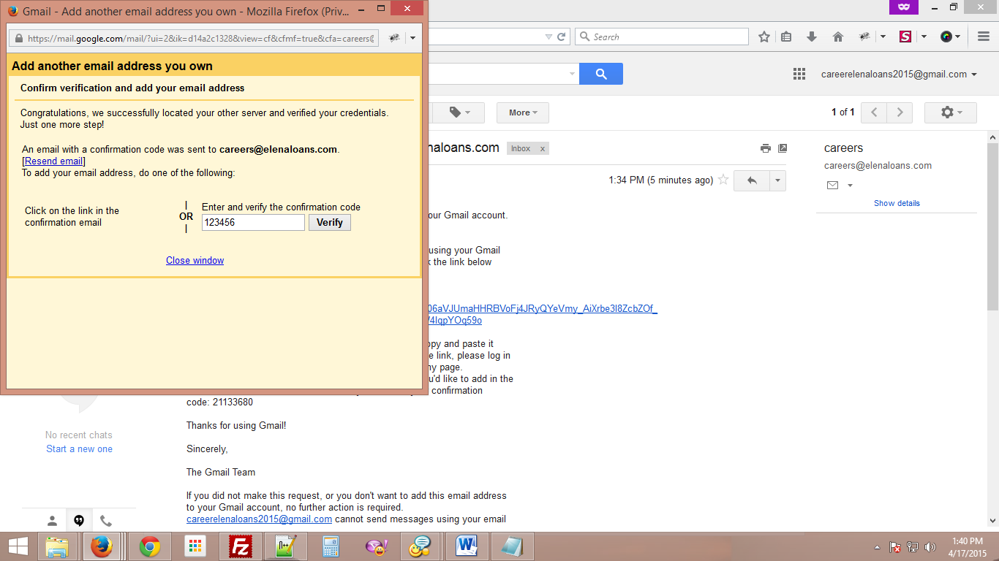

15. In Gmail Account, Click “Gear Icon” -> “Settings” -> “Accounts and Import”, Update setting under “Send mail as”.

* Make default the Webmail Account created
* Select “Always reply from default address…”

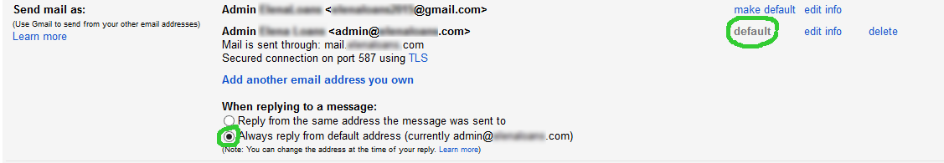

16. Done.

* All email sent to admin@example.com (Webmail Account created) will transfer to admin@gmail.com (Gmail Account created)
* All reply of admin@gmail.com (Gmail Account created) to a sender will see admin@example.com (Webmail Account created) in the “From” of the email reply sent.